**Exp 02 : Create a simple cloud software application for Flight Reservation System using**

**any Cloud Service Provider to demonstrate SaaS.**

**Aim**

To create a simple cloud-based application using **Zoho Creator** and provide it as a service through the **Software as a Service (SaaS)** model, allowing users to access and use the application online.

**Procedure**

1. Login to Zoho Creator – Sign in to Zoho Creator using your credentials to access the app-building platform.
2. Create a New Application – Choose “Create Application” and select a blank app or template.
3. Design Forms & Modules – Add forms (e.g., user details, booking/property info) and fields as per requirements.
4. Set Workflows & Logic – Define workflows, validations, and automation to handle user actions.
5. Deploy the Application – Save and deploy the app on the Zoho cloud platform.
6. Provide SaaS Access – Share the application link with users so they can use it online as a SaaS.

**Output**

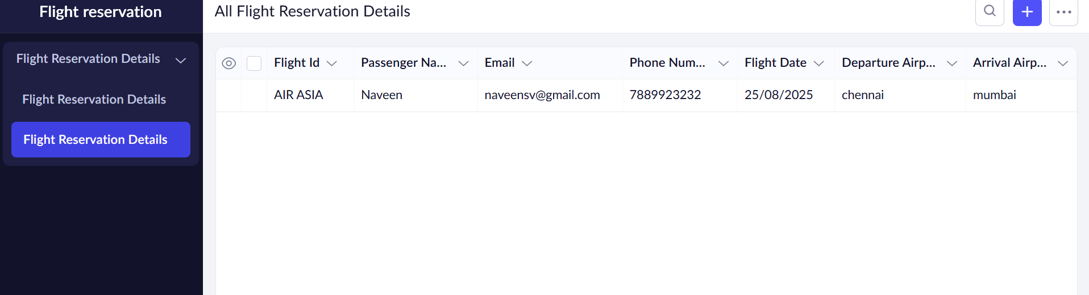

**Result**

Thus, a simple cloud-based application was successfully created and deployed using **Zoho Creator**, and it was provided as a **Software as a Service (SaaS)** model for end-users to access online.